ACTIVITY: Space Shuttle Crossword
Directions:
Complete the following crossword puzzle using your answers to the descriptions below.
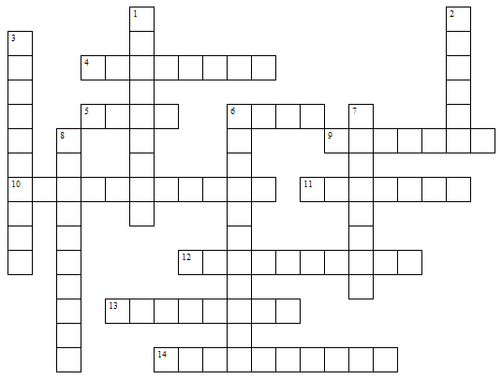
Across |  | Down
- The center of the orbiter’s fuselage that holds the payload.  - Landing gear located under this front end of the obiter.  - Landing gear located under the orbiter’s belly.  - Commander of STS-93.  - A control surface located on the vertical stabilizer controlling yaw.  - Opens the cargo bay.  - Located on the trail section it slows the orbiter’s speed.  - A control system using as set of engines located on each side of the aft fuselage during re-entry. First word only.  - Part of the crew compartment. |  | - Small rocket engines located around the orbiter’s nose, which are the forward control.  - A control surface that combines the work of an aileron and an elevator.  - What the 3 Space Shuttle Main Engines (SSME) give.  - Engine system used to move the orbiter into orbit and out of orbit. Middle word used.  - A hinged control surface connected to the aft fuselage.  - Triangular shaped wings.

